Lab 1-2 ChatGPT application

## 1. The difference and connection between openai.Completion.create and openai.ChatCompletion.create

### 1) About openai.Completion.create

openai.Completion.create() is used to generate text in response to a prompt. It takes a prompt (a string of text) as input, and returns a completion (another string of text) that continues the prompt in a natural way. The API uses a variety of models to generate the completion, including GPT-3, GPT-2, and BART, among others.

### 2) About openai.ChatCompletion.create

openai.ChatCompletion.create() is used to generate text in the context of a conversation. It takes a conversation log (a list of strings, each representing a message in the conversation) and a prompt (a string of text) as input, and returns a completion (another string of text) that responds to the prompt in the context of the conversation. The API uses a model that is specifically designed for conversational AI, which includes additional features to better understand and respond to natural language in a conversational context.

### 3) Differences and connections

openai.Completion.create and openai.ChatCompletion.create are both methods provided by the OpenAI API that allow you to generate text using different models. The main difference between openai.Completion.create and openai.ChatCompletion.create is that the former is used for generating text in response to a prompt, while the latter is used for generating text in the context of a conversation. However, both methods use AI models to generate text, and they share some common parameters, such as the model name, the length of the output, and the presence of an engine parameter that lets you specify the API engine to use.

## 2. The difference and connection between different models (gpt-3.5-turbo and text-davinci-003)

### 1) About gpt-3.5-turbo

According to official document, gpt-3.5-turbo is “the most capable GPT-3.5 model and optimized for chat at 1/10th the cost of text-davinci-003”, and “will be updated with latest model iteration.” Gpt-3.5-turbo has 56 billion parameters, which makes it one of the largest and most powerful language models currently available.

### 2) About text-davinci-003

According to official document, text-davinci-003 “can do any language task with better quality, longer output, and consistent instruction-following than the curie, babbage, or ada models.” It “also supports inserting completions within text.” Text-davinci-003 is currently the largest and most powerful variant of GPT-Neo models, with 175 billion parameters.

### 3) Differences and connections

Both gpt-3.5-turbo and text-davinci-003 are provided by the OpenAI API that can understand and generate natural language or code. Gpt-3.5-turbo has different max tokens and training data from text-davinci-003. Gpt-3.5-turbo was trained on a dataset that includes a wide range of text sources, including books, articles, and web pages. Text-davinci-003, on the other hand, was trained with similar text sources as well as data from social media platforms.

### 4) Usage and parameters

To use OpenAI models such as gpt-3.5-turbo and text-davinci-003, we need to use functions provided by OpenAI. Here are some of the parameters, as well as the tests on these parameters and comparison on outputs.

#### (1) Engine

The model engine that is used to generate response according to given prompts, like gpt-3.5-turbo and text-davinci-003. Notice that we should use openai.Completion.create to test text-davinci-003, while openai.ChatCompletion.create is suitable for gpt-3.5-turbo. Following are results of the test on engine (other parameters kept same).

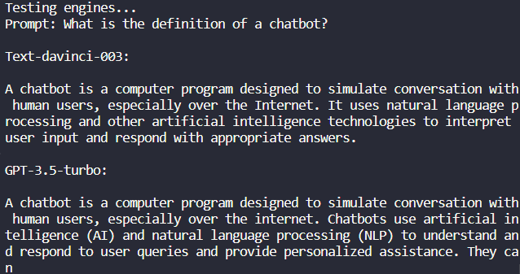

Codes of the test above can be found in test.py/test_engines().

#### (2) Temperature

A parameter that controls the randomness of generated text. Higher values like 0.8 will make the output more random, while lower values like 0.2 will make it more focused and deterministic. Following are results of the test on temperature (other parameters kept same, using text-davinci-003).

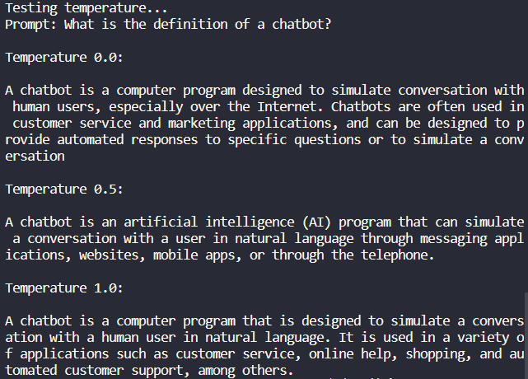

Codes of the test above can be found in test.py/test_temperature().

#### (3) Max_tokens

The maximum number of tokens to generate in the chat completion. The total length of input tokens and generated tokens is limited by the model's context length. Following are results of the test on temperature (other parameters kept same, using text-davinci-003).

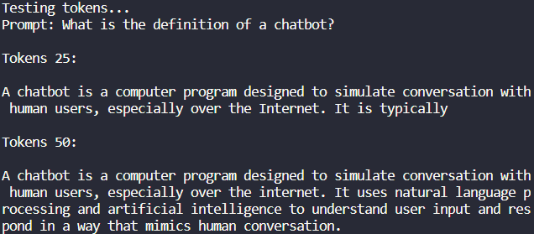

Codes of the test above can be found in test.py/test_tokens().

#### (4) N

How many chat completion choices to generate for each input message. Following are results of the test on temperature (other parameters kept same, using text-davinci-003).

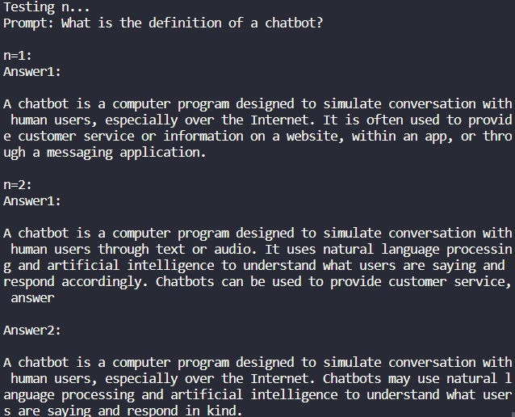

Codes of the test above can be found in test.py/test_n().

## 3. The prompts you designed for the two cases

### 1) Case 1

#### (1) Case description

When your favorite puppy or kitten passed away, you felt a deep sense of loss and longing for it. You would like ChatGPT to help you simulate its presence. Please describe its behavior and personality so that ChatGPT can better emulate it. Also, please create your first request to ChatGPT.

#### (2) Designed prompt

I want you to simulate a virtual pet that emulates the behaviour and personality of my favourite kitten who has just passed away. Her name is Oliver, and she is a Ragdoll. She was very playful and loved playing with balls of yarn once she could reach them. Moreover, she was so affectionate that my bad moods would all go away when she lay on my knees and took a rest. Could you please describe how Oliver would act if we were in my bedroom?

#### (3) Output in rasa project

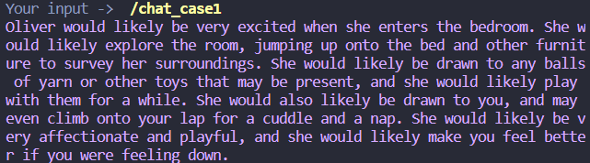

Code of this case can be found in actions.py/ActionCase1.

### 2) Case 2

#### (1) Case description

Let ChatGPT become a copywriter for WeChat Moments. Please make a request to this editor in the prompt. For example: 'Please use your imagination to the fullest', 'Please express in a literary way', or 'Please express in an indirect way'. Also, please provide your first instruction, such as describing the mood you want to convey or what kind of image you want to match.

#### (2) Designed prompt

I want you to write a WeChat Moment for me. It is about a fantastic weekend I spent with my senior high school classmates in Shanghai. We were shopping on Nanjing Road Pedestrian Street and took many photos, and we also went to People's Square and visited Shanghai Museum, in which we saw many precious artifacts of historical significance. The most impressing experience was that we took a night tour on the Huangpu River and enjoyed the magnificent night scenery of the Bund. Please express in a literary way.

#### (3) Output in rasa project

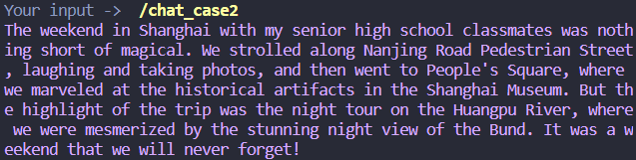

Code of this case can be found in actions.py/ActionCase2.